The Harbor Ridge Homeowner
A Publication of the Harbor Ridge Homeowners Association WINTER 2009
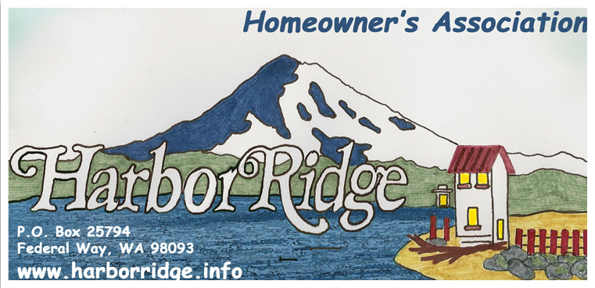

The 2009 Annual Meeting will be at the Northeast Tacoma Police Substation, on Sunday, January 25th, at 3:00 p.m.
All Harbor Ridge homeowners are invited to participate.
This Newsletter serves as the announcement for the meeting.

(Note: This is the Sunday before the Superbowl, which is on February 1)

AGENDA:
- INTRODUCTIONS
- RE-CAP OF 2008 (see highlight on reverse side)
- PLANS FOR 2009
- ELECTION OF BOARD MEMBERS
- SOCIAL TIME

Thank You - for all who have made the effort to keep their homes and yards in such excellent upkeep. There was no way to single out any one home, because almost everyone is doing so much to maintain their homes. This is particularly appreciated in view of the challenging financial time period we are experiencing as a nation. Photographs of some of the representative well-kept homes in our community have been placed on our web site. http://www.harborridge.info/Projects.cfm

‘Be Green’ option - Members can provide us with their e-mail addresses if they would like to have the periodic Newsletters sent to them by e-mail, rather than mailed or delivered to their doorstep. This would save us printing and mailing costs as well.

Dues for 2009– Please bring your $35 annual dues payment to the annual meeting, or mail to:

Harbor Ridge Homeowners Association
P.O. Box 25794
Federal Way WA 98093 – 2794

HIGHLIGHTS OF 2008

  - The Board met at the NE Tacoma Police substation at 7:00 PM on the 4th Wednesday of almost every month to work on issues and topics concerning the Harbor Ridge community. These meetings are announced on the readerboard and Harbor Ridge website, and are open to all.

  - Periodic Newsletters were either mailed or distributed to the homes in our community.

  - New features were added to the Web Site. Harbor Ridge Residents browsed projects, events, activities, communicated and requested additional information from their Board via http://www.harborridge.info

  - The Board established spring landscaping volunteer weekends to enhance the appearance of the 3 front entryways, including weeding, cleaning, planting flowers and adding new beauty bark.

  - The Sprinkler Systems for two main entryways were redesign and enhanced to provide an even and better water distribution to the landscape areas, as the Association continues to financially cover for the annual water usage cost for these areas.

  - The Board negotiated with Qwest to repair damaged sidewalk in main entrance area until it was satisfactorily replaced

  - A professional landscaper was hired to maintain and care for the improvements made to the 3 front entryways. Photographs of the changes to the landscape areas have been placed on our web site.

  - Participation by homeowners reached a new high, as 74 dues-paying households enabled the continuing efforts of the Association to benefit our neighborhood.

  - The Board sponsored a Neighborhood Summer Social/Block Party was held in the Resurrection Lutheran Church parking area as part of the National Night Out/Safe Streets County Campaign. Chairman Mike Doran and volunteers of the event organized activities and entertainment including live music, children’s games, BBQ and sodas, for more 100 participants. The Social. Photographs of the event have been placed on our web site.

Considering Re-roofing Soon?

Homeowners in our community with shake roofs either already have, or soon will be facing the roof replacement issue. For those whom this will affect, your Architectural Control Committee (ACC) provides some choices.

Roofs are a major architectural element in setting the tone, in a physical sense, for a home and for a community. That was reflected in the Architectural Guidelines established by the Harbor Ridge Plat developer. Roofs in our community originally were either wood (shakes), with a relatively short life, or concrete tiles, with a considerably longer life.

Shake roofs usually were installed over intermittent wooden strips, to save costs. This is referred to as skip sheathing. The simplest and least expensive re-roofing alternative is to replace existing shakes with new shakes. However, finding good quality shakes can be difficult. Regular roof maintenance is almost mandatory, roof life will again be limited, and insurance cost is higher than with other roof materials because of the fire hazard associated with wood.

ACC approved roof materials, in addition to shakes, that can be used with the same roof support structure you currently have, although full sheathing will likely be required, are:

- An estate quality laminate composite shingle. The requirement is a quality product with at least a 40-year warrantee. Since the cost of installation will be very little more for better shingles than for a lower grade shingle, it makes sense to assure that you spend the incremental amount for the material cost to assure you are installing a good product.

- Light-weight concrete tile. The only one we are aware of at this time is Monier Premium Duralite 2000.

- Metal products produced in sheet stock made to simulate shingles or tile. The ones that have been approved to this point are: Metal Works ‘Aston Woods’ steel, and Interlock ‘Super Aluna’ aluminum.

These options in general are more expensive, up front, than redoing shakes. We expect that new developments in materials and business competition will result in other acceptable options in the future.

Contractors and/or owners who choose to build on the currently vacant lots in Harbor Ridge are now offered these same expanded roofing options.

Based on discussions with the City of Tacoma Building Department personnel, it is our understanding that no building permit is required either for redoing shakes or for the above-listed alternatives. A structural inspection and a building permit are required if you choose to upgrade your roof structure for the conventional, heavy weight tile. For questions with regard to permits, call the Building Department at (253) 591-5004.

We strongly urge you to call the Washington State Department of Labor and Industries at (253) 596-3800 to evaluate a roofing contractor’s licensing and bonding before you agree to the work. This can be vital in the event of subsequent contract disagreements.

The ACC can assist you in making an informed decision about re-roofing your home. We would be pleased to review the material you are considering. If you have questions, or wish to have the ACC consider materials other than those approved and described in this article, please don’t hesitate to contact
Dietrich Brunner, Christine Smith – ACC
(253) 927-7743 (253) 568-7220

